***LAB 4***

**Name : SohaibSarosh Shamsi**

**Section : E**

**Roll No. : 21K-3278**

1. A man wants to go for tour of different countries. He has 10000000 PKR initially, He

decided to take a tour of France, England, Spain, Canada and Japan. He decided to

divide this amount equally, i.e. 2000000 for each country tour. Write a Program to

convert the divided amount (which is in Pakistani rupees) into Swiss franc, Pound

Sterling, Spanish Euro, Canadian Dollar and Japanese Yen.

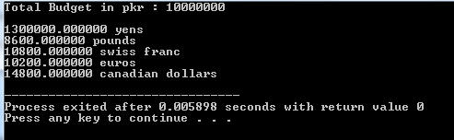  
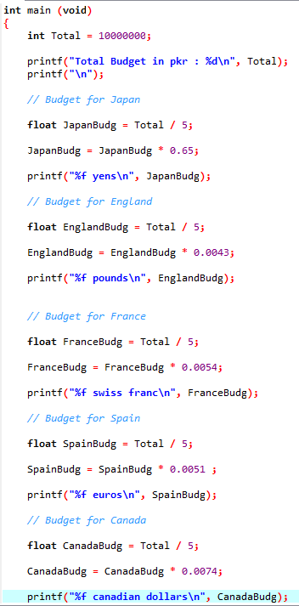

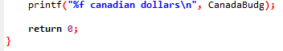

2. One of the jobs that Joe Roberts has been given at work is to order special paper for a

report for a board meeting. The paper comes in reams of 500 sheets. He always makes

five more copies than the number of people that will be there. Joe wants to know how

many reams of paper he needs for a meeting. He can order only whole, not partial,

reams. Assume the required number of pages will not equal an exact number of reams.

Test your solution using scratch with the following data:

The report is 140 pages long.

There will be 25 people at the meeting.

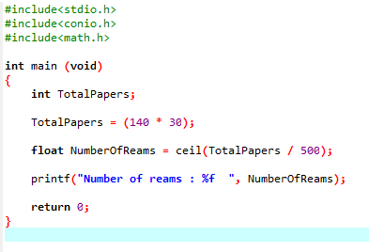

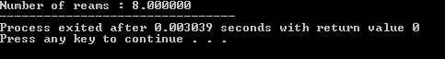

4. Write a C program that takes temperature in Celsius and converts it into Fahrenheit and

Kelvin.

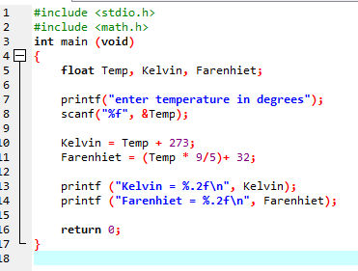

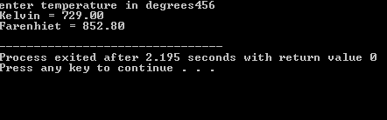

5. Write a C program that takes user year of birth as input and tell him/her his age (in

years only) in 2021.

Sample output:

Enter your birth year: 1997

Your age in 2021 = 24 years

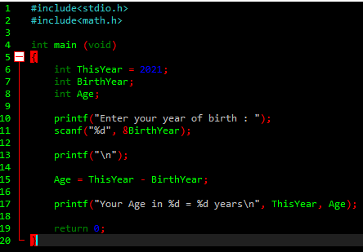

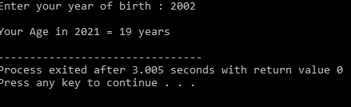

6. Write a C program to Find out distance, coordinates of midpoint using distance formula,

derived from Pythagorean Theorem and value of X by Quadratic formula, as follows:

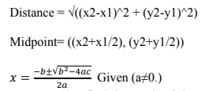

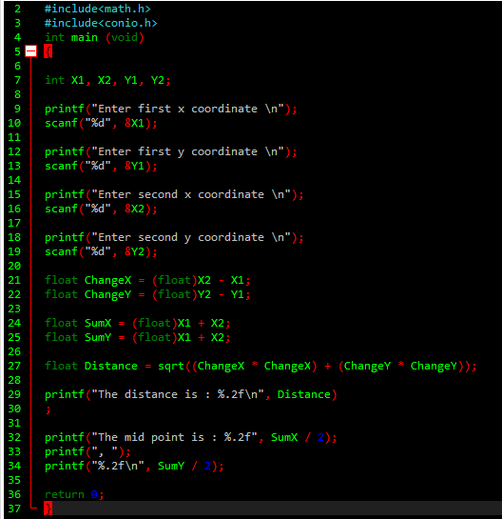

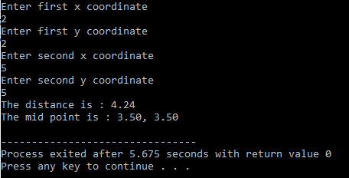

8. In a cricket match between England and New Zealand, England gave the target of 282

runs. In the first 10 overs of a cricket game, the run rate of New Zealand was only 3.2

runs. Write a C program to calculate the run rate in the remaining 40 overs to reach the

target of 282 runs.

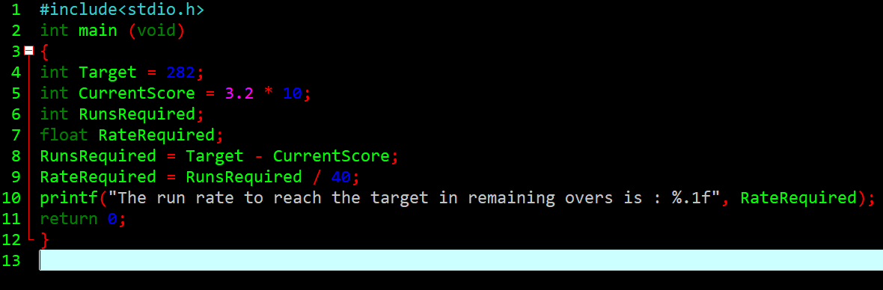

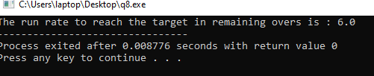

9. A shopkeeper sells watches in 45 rupees each. He purchased watches for Rs. 20 per

piece. Write a C Program to calculate profit and profit percentage.

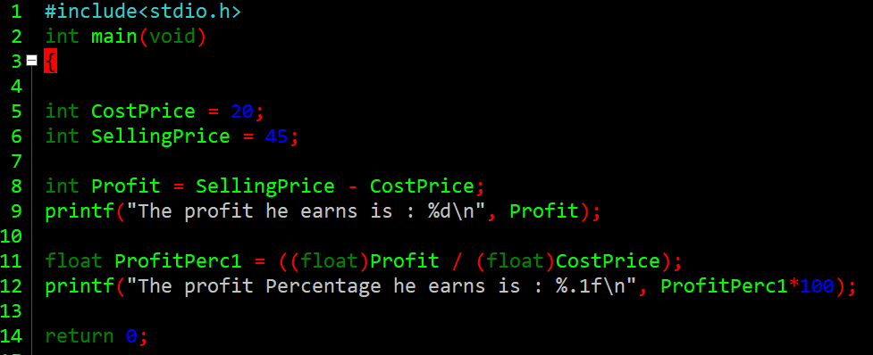

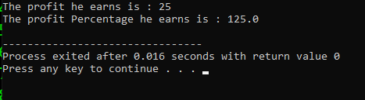

10.

a) 600-meter-long distance was crossed by a man in 5 minutes. Construct a C Program

to find out the speed in km per hour.

b) Calculate the hypogenous for a right-angle triangle in which user inputs base and

perpendicular of a triangle. Use functions from Math.h library to calculate square.

Answer a)

